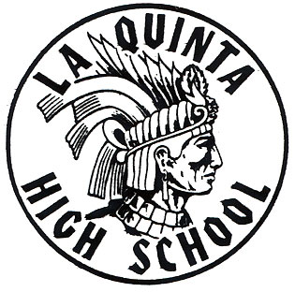
Daily Bulletin
January 29

TODAY’S SPORTS

FS Girls Basketball @ Bolsa 3:00 pm
JV Girls Basketball Bolsa @ LQ 3:00 pm
JV Boys Soccer Bolsa @ LQ 3:00 pm
JV Girls Soccer @ Bolsa 3:00 pm
JV Girls Water Polo @ GG 4:00 pm
JV Boys Basketball Bolsa @ LQ 4:30 pm
FS Boys Basketball @ Bolsa 4:30 pm
V Boys Soccer @ Bolsa 5:00 pm
V Girls Basketball @ Bolsa 6:00 pm
V Girls Water Polo @ GG 6:00 pm
V Girls Soccer @ Bolsa 7:00 pm
V Boys Basketball @ Bolsa 7:30 pm

FINAL EXAM SCHEDULE

Period 0 7:00AM - 7:55 AM
Period 6 8:00 AM - 9:24 AM
Break 9:24 AM - 9:34 AM
Period 5 9:34 AM - 10:57 AM
Break 10:57 AM - 11:07 AM
Period 4 11:07 AM - 12:30 PM

Announcements

Attention All AP Science Students! UC Berkeley and UC San Diego are offering four full scholarships and several partial scholarships for summer camps! If you want to pursue a career in medicine or related fields, such as pharmacy, nursing, biomedical research or drug development. Here is a chance to attend a Summer Science Camp at UC Berkeley or UC San Diego on Molecular Biology of Cancer and Molecular neuroscience. You would stay in university housing and attend camps to engage in lectures and hands-on laboratory work, as well as independent research. Make friends with students from around the world. Please see Ms. Grelle for scholarship information. Deadline is March 15!
Students who are interested in ROP class for spring, please stop by the Guidance Office and see Ms. Bhoot.
Class of 2018 will be hosting a BOOOOOOOWWWWLLLIIIIINNNNGGG EEEVENT!
It will be at Fountain Bowl on February 7th! Tickets will be $15 and on sale this week!
My Dream Photo Contest: Attention all students! Photo Contest! What do you want to do as your Dream Career? Whether you want to be an auto mechanic or veterinarian, a doctor or a singer, the possibilities are endless! Have someone snap a picture of you demonstrating your “dream career” and you could win up to $300! See Ms. Grelle for application details. Deadline is March 12, 2015.
Boeing Aerospace Leadership: Attention 9 grade thru 12 grade! The Boeing Corporation is offering a Speech contest! A 4 to 6 minute speech relating to leadership. Prizes range from $500 - $4,000. See Ms. Grelle for details! Deadline is February 18th!

The Lions Club Student Speaker Contest: Attention all students! The Lions Club of California is having a Student Speaker Contest at the Garden Grove Lions Club! All you have to do is write a 5 to 10 minute speech on “Water Conservation – How Can We Reduce, Recycle, and Reclaim?” Just for entering you will automatically receive $25, a catered dinner for 2, and a Certificate of Completion for 25 hours of Community Service! If you win, you will receive anywhere from $100 to $10,000! See Ms. Grelle for rules and details! Don’t miss this great opportunity! Deadline is Feb 18!

